EMRS BACnet Compliance Test Readiness Form – Vendor Specific Template for B-BC controllers (ETHERNET Interface only)
IMPORTANT NOTE:
- The content of all the screenshots must be easily read. Failure to provide properly captured and easy to read screenshot will result in a delay of the approval process.
- Use the template for the BAS Vendor only. Remove the template for not applicable BAS vendor.

EMRS Bacnet Compliance Test Readiness Form
BAS Controls Contractor:
- Johnson Controls (JCI)
- Siemens (SBT)
- Honeywell (HBS)

BAS Controls Contractor Team,
We are in the preparation phase for the EMRS Bacnet Compliance Testing.

Below is the list of project(s) and the most current submittal of the mandatory documentation.
List of project(s):
<insert UofT Project Identification> ex. P001-19-123 Main Building BAS Retrofit)
As-Built Drawings – Network Architecture:
To be provided for all projects by BAS Controls Contractor. All drawings should have some references to the project numbers for the effective identification. The final markup drawings that reflects the completed state of the project are also acceptable.
The network architecture drawing is sufficient to show the B-BC and ASC/AAC riser for each B-BC. For the ASC/AAC architecture, the device count and traditional ASC/AAC schedule is sufficient, if exists.

EMRS Bacnet Implementation Metafile:
<insert the reference to the EMRS Bacnet Implementation Metafile> , ex. P001-19-123 Main Building BAS Retrofit EMRS_BACNET_Implementation_Requirements_v3.0_05SEP2018.xlsx
Wiring Installation Qualification Document:
<insert the reference to the Wiring Installation Qualification document based on the template listed here:
https://www.fs.utoronto.ca/wp-content/uploads/standards/bas/Wiring Installation Qualification Form.docx

IMPORTANT NOTE:
The attached documents must be reviewed by BAS Controls Contractor team as the documents will be used for the EMRS Bacnet Compliance Testing. Since all the information was shared, it is expected that the accuracy of the documentation will match the current on site installation.
It is the responsibility of the BAS Controls Contractor to provide the proper information.
Any discrepancy between the documentation and the actual status during the compliance test will be flagged as FAILED.
ACTIONS REQUIRED:
- BAS Controls Contractor to provide the as-built drawings or the final markup drawings that reflects the completed state of the projects. The network architecture drawings is sufficient to show the B-BC and AAC/ASC device count and the .
- BAS Controls Contractor to provide the final confirmation that the projects are Network Ready and EMRS Ready.
  - Network Ready – YES --- NO
    - IP device can be pinged from the properly labeled patch panel based on the document: < Wiring Installation Qualification Document >
  - EMRS Ready – YES --- NO
    - B-BC and ASC/AAC are configured with the Bacnet Instance numbers and Bacnet Object names based on the document: < EMRS Bacnet Implementation Metafile >
    - B-BC has properly defined Alarm Notification Classes based on the UofT BAS Standard
    - B-BC and ASC/AAC have properly configured Bacnet Change of Value properties for all Analog Inputs and Analog Outputs
- BAS Controls Contractor to provide specific report “EMRS Bacnet Compliance Test Readiness Form.docx” based on the template listed here:
https://www.fs.utoronto.ca/wp-content/uploads/standards/bas/EMRS BACnet Compliance Test Readiness Form.docx
- BAS Controls Contractor to provide specific report “Project Points List EMRS Submittal Form.xlsx” based on the template listed here:
https://www.fs.utoronto.ca/wp-content/uploads/standards/bas/Project Points List EMRS Submittal Form.xlsx

- UofT F&S IT : On site EMRS Compliance Testing (Total of # B-BC controller) – expected completion: up to 5 business days following EMRS Ready report
- UofT F&S IT : Final Report (pending on the test results) – expected completion: up to 5 business days following EMRS Ready report
- UofT F&S IT : EMRS Integration (alarms, history trends) - expected completion: up to 5 business days following the Final Report
- UofT F&S IT : EMRS Integration GUI (pending the final commissioning report) - expected completion: up to 6 weeks following the EMRS Integration

HONEYWELL (HBS)
Device Name | Fluke Report Cable ID | Digital Picture(s) of the device TELNET session indicating the current system time and TCP IP settings: | Digital Picture(s) of the device TELNET session indicating the PORT CONFIGURATION INFORMATION | Digital Picture(s) of the device TELNET session indicating the CONTROLLER DEVICE INFORMATION | Date / Initials
EXAMPLE: 005_DDC01 | 005_DDC01 | 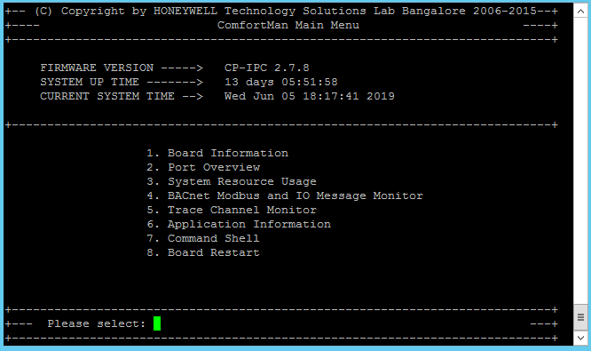  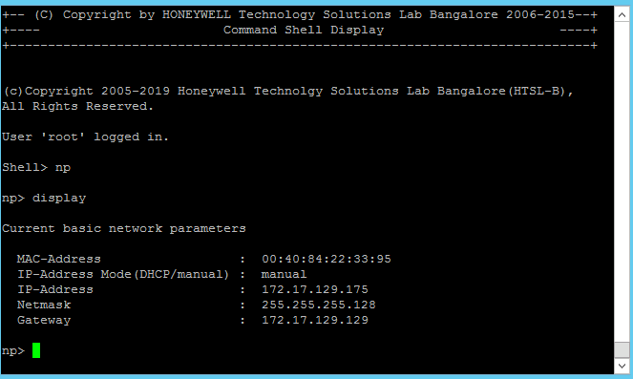 | 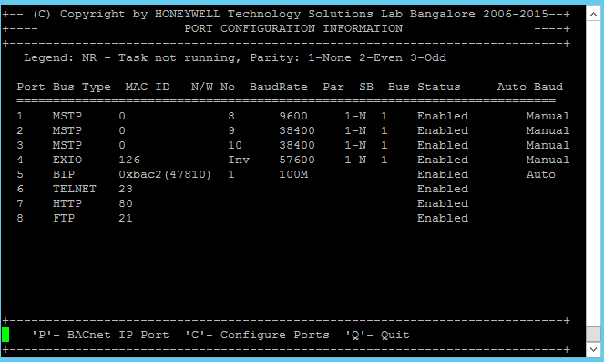 | 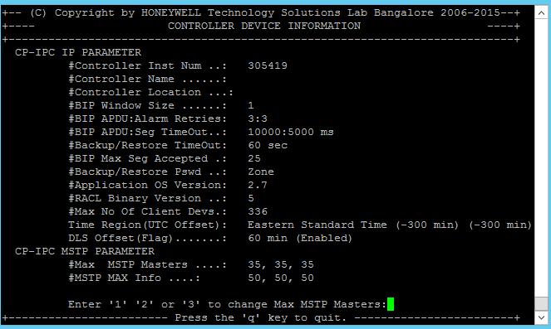 | 01-MAR-2019, AB

SIEMENS (SBT)
Device Name | Fluke Report Cable ID | Digital Picture(s) of the device TELNET session indicating the TCP IP settings: | Date / Initials
EXAMPLE: 080_DDC03 | 08s  0_DDC03 | 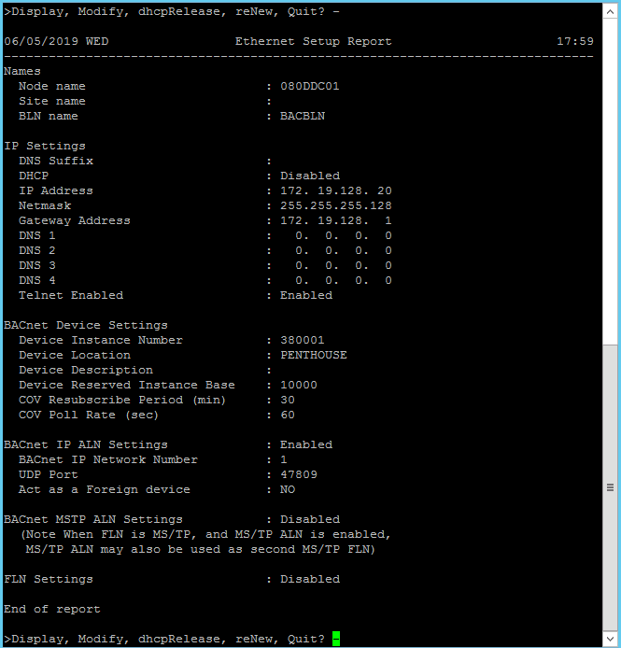 | 01-MAR-2019, AB

Johnson Controls (JCI)
Device Name | Fluke Report Cable ID | Digital Picture(s) of the device Launcher session indicating the Local Server time and the TCP IP settings: | Digital Picture(s) of the device TELNET session indicating the PORT CONFIGURATION INFORMATION | Date / Initials
EXAMPLE: 070_DDC01 | 070_DDC01 | 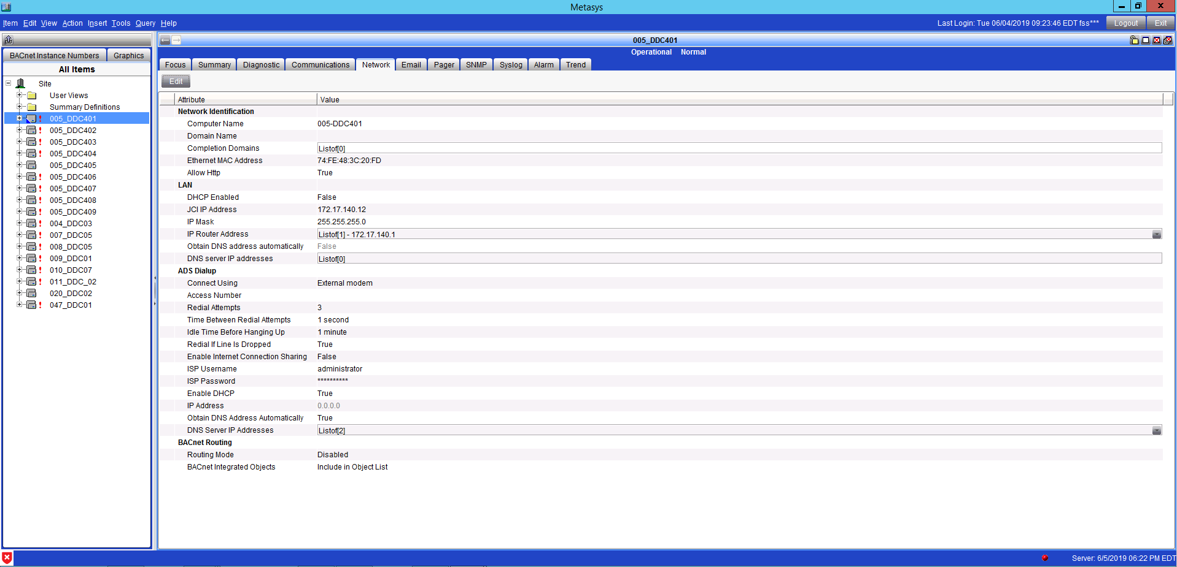 | 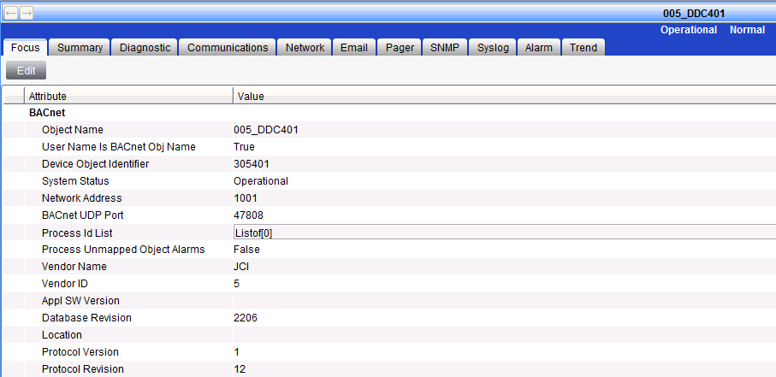 | 01-MAR-2019, AB

START HERE:
Device Name | Fluke Report Cable ID | Digital Picture(s) of the device TELNET session indicating the current system time and TCP IP settings: | Digital Picture(s) of the device TELNET session indicating the PORT CONFIGURATION INFORMATION | Digital Picture(s) of the device TELNET session indicating the CONTROLLER DEVICE INFORMATION | Date /Initials

